|  |
| --- |
| Day-7 Morning Assignment  By  U.Joshna  [01-2-2022] |

|  |
| --- |
| Program-1: |
| Create Employee class with three variables and two methods ReadEmployee and PrintEmployee and Create an object and call methods? |
| Code: |
| using System;  using System.Collections.Generic;  using System.Linq;  using System.Text;  using System.Threading.Tasks;  namespace Day_7_Mrng_Assignment1  {  class Employee  {  private int id;  private string name;  private int salary;  public void ReadEmployee()  {  Console.WriteLine("Enter Id Num :");  id = Convert.ToInt32(Console.ReadLine());  Console.WriteLine("Enter Your Name :");  name = Console.ReadLine();  Console.WriteLine("Enter Your Salary :");  salary = Convert.ToInt32(Console.ReadLine());  }  public void PrintEmployee()  {  Console.WriteLine($"Id={id},Name={name},Salary={salary}");  }  }  internal class Program  {  static void Main(string[] args)  {  Employee emp1 = new Employee();  emp1.ReadEmployee();  emp1.PrintEmployee();  Console.ReadLine();  }  }  } |
| Output: |
|  |
|  |
|  |

2.Write the 3 def of class and 4 points about object discussed in the class?

Class:

.A class Consists of state and Behaviour ,A class enables we to create your custom types by Grouping Variables of other types, methods and events

.A class is Group of Variables and Methods

.A class is like a blueprint to Create Objects

Object:

.We can Create any Number of objects

.An Object is an instance of a Class

.Objects are Reference Type

3.Pictorially represent class and multiple objects?

Class Objects

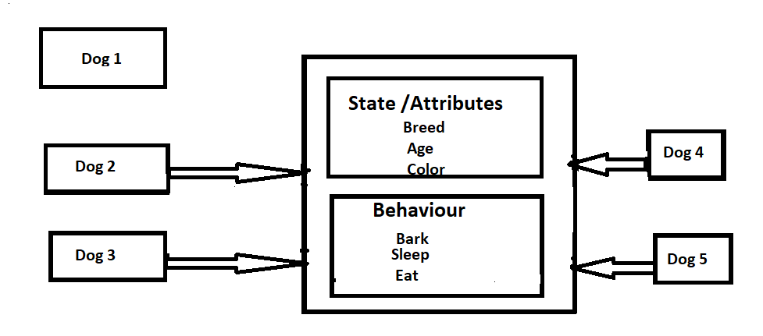

|  |
| --- |
| Program-4 |
| Create below Classes:  1.Custmor  2.Product  3.Seller  4.Department |
| A) WACP Custmor Class?  Code: |
| using System;  using System.Collections.Generic;  using System.Linq;  using System.Text;  using System.Threading.Tasks;  namespace Day_7_Mrng_Assignment_4a  {  class Customer  {  private string name;  private string email;  private long mobile;  private string address;  public void ReadCustomer()  {  Console.WriteLine("Enter your Name :");  name = Console.ReadLine();  Console.WriteLine("Enter Your Email :");  email = Console.ReadLine();  Console.WriteLine("Enter Your Mobile Number :");  mobile = Convert.ToInt32(Console.ReadLine());  Console.WriteLine("Enter Your Address :");  address = Console.ReadLine();  }  public void PrintCustomer()  {  Console.WriteLine($"Name={name},Email={email},Mobile={mobile},Address={address}");  }  }  internal class Program  {  static void Main(string[] args)  {  Customer cust = new Customer();  cust.ReadCustomer();  cust.PrintCustomer();  Console.ReadLine();  }  }  } |
| Output: |
|  |
| 4B)WACP to Product Class? | |
| Code: | |
| using System;  using System.Collections.Generic;  using System.Linq;  using System.Text;  using System.Threading.Tasks;  namespace Day_7_Mrng_Assignment_4_b  {  class Product  {  private int id;  private string name;  private string description;  private double price;  public void ReadProduct()  {  Console.WriteLine("Enter Your Product Id : ");  id = Convert.ToInt32(Console.ReadLine());  Console.WriteLine("enter your Product name : ");  name = Console.ReadLine();  Console.WriteLine("enter your Product Description :");  description = Console.ReadLine();  Console.WriteLine("enter your Product price :");  price = Convert.ToDouble(Console.ReadLine());  }  public void PrintProduct()  Console.WriteLine($"id={id},name={name},Descr={description},price={price}");  }  }  internal class Program  {  static void Main(string[] args)  {  Product product = new Product();  product.ReadProduct();  product.PrintProduct();  Console.WriteLine();  }  }  } | |
| Output: | |
|  | |
|  | |
|  | |
|  | |

|  |
| --- |
| 4C)WACP to print Seller class? |
| Code: |
| using System;  using System.Collections.Generic;  using System.Linq;  using System.Text;  using System.Threading.Tasks;  namespace Day_7_Mrng__Assignment_4_c  {  class Seller  {  private int id;  private string name;  private long mobile;  private string address;  public void ReadSeller()  {  Console.WriteLine("Enter Your seller Id : ");  id = Convert.ToInt32(Console.ReadLine());  Console.WriteLine("enter your Seller name : ");  name = Console.ReadLine();  Console.WriteLine("enter your seller mobile :");  mobile = Convert.ToInt32(Console.ReadLine());  Console.WriteLine("enter your Seller Address :");  address = Console.ReadLine();  }  public void PrintProduct()  {  Console.WriteLine($"id={id},name={name},mobile={mobile},address={address}");  }  }  internal class Program  {  static void Main(string[] args)  {  Seller sell = new Seller();  sell.ReadSeller();  sell.PrintProduct();  Console.ReadLine();  }  }  } |
| Output: |
|  |
|  |
|  |
| 4D)WACP Depatrment Class? |
| Code: |
| using System;  using System.Collections.Generic;  using System.Linq;  using System.Text;  using System.Threading.Tasks;  namespace Day_7__Mrng_Assignment_4_d  {  class Department  {  private int id;  private string name;  private long mobile;  private string branch;  public void ReadDepartment()  {  Console.WriteLine("Enter Your Department Id : ");  id = Convert.ToInt32(Console.ReadLine());  Console.WriteLine("enter your Department name : ");  name = Console.ReadLine();  Console.WriteLine("enter your Department mobile :");  mobile = Convert.ToInt32(Console.ReadLine());  Console.WriteLine("enter your Department branch :");  branch = Console.ReadLine();  }  public void PrintDepartment()  {  Console.WriteLine($"id={id},name={name},mobile={mobile},branch={branch}");  }  }  internal class Program  {  static void Main(string[] args)  {  Department department = new Department();  department.ReadDepartment();  department.PrintDepartment();  Console.ReadLine();  }  }  } |
| OutPut: |
|  |
|  |
|  |
|  |

|  |
| --- |
| 5.Create Employee class with 3 public variables.  Create Employee object and initialize with values while creating object and print the values. |
| Code: |
| using System;  using System.Collections.Generic;  using System.Linq;  using System.Text;  using System.Threading.Tasks;  namespace Day_7_Mrng_Assignment_5  {  class Employee  {  public int id;  public string name;  public int salary;  }  internal class Program  {  static void Main(string[] args)  {  Employee emp1 = new Employee() { id = 1, name = "joshna", salary = 30000};  Console.WriteLine($"id={emp1.id},name={emp1.name},salary={emp1.salary}");  Console.ReadLine();  }  }  } |
| Output: |
|  |
|  |
|  |
|  |

|  |
| --- |
| Program-6 |
| Create Employee class as shown below ,now create employees array object and initialize with 4 employees,write code using  a.for loop  b.foreach loop  c.lambda expression. |
| Code: |
| using System;  using System.Collections.Generic;  using System.Linq;  using System.Text;  using System.Threading.Tasks;  namespace Day_7_Mrrng_Assignment_6  {  Class  Employee  {  public int id;  public string name;  public int salary;  }  internal class Program  {  static void Main(string[] args)  {  Employee[] employees = new Employee[]  {  new Employee(){id=1,name="lakshna",salary=4000},  new Employee(){id=2,name="renuka",salary=8000},  new Employee(){id=3,name="kushal",salary=9000},  new Employee(){id=4,name="joshna",salary=5000},  };  //for loop  for (int i = 0; i < employees.Length; i++)  {  Console.WriteLine($"id={employees[i].id},name={employees[i].name},salary={employees[i].salary}");  }  //forEach  foreach (var e in employees)  {  Console.WriteLine($"id={e.id},name={e.name},salary={e.salary}");  }  //lamda experssion  employees.ToList().ForEach(e=>Console.WriteLine($"id={e.id},name={e.name},salary={e.salary}"));  Console.ReadLine();  }  }  } |
| Output: |
|  |
|  |
|  |

|  |
| --- |
| Program-7 |
| For the above Project,  Write code to print employees who is getting salary>=5000 using for loop, foreach loop,lambda expression. |
| Code: |
| using System;  using System.Collections.Generic;  using System.Linq;  using System.Text;  using System.Threading.Tasks;  namespace Day_7_Mrng_Assignment_7  {  class Employee  {  public int id;  public string name;  public int salary;  }  internal class Program  {  static void Main(string[] args)  {  Employee[] employees = new Employee[]  {  new Employee(){id=1,name="lakshna",salary=5000},  new Employee(){id=2,name="renuka",salary=7000},  new Employee(){id=3,name="kushal",salary=15000},  new Employee(){id=4,name="joshna",salary=4000},  };  //for loop  for (int i = 0; i < employees.Length; i++)  {  if (employees[i].salary >= 5000)  Console.WriteLine($"id={employees[i].id},name={employees[i].name},salary={employees[i].salary}");  }  //forEach  foreach (var e in employees)  {  if (e.salary >= 5000)  Console.WriteLine($"id={e.id},name={e.name},salary={e.salary}");  }  //lamda experssion  employees.ToList().Where(e => e.salary >= 5000).ToList().ForEach(e => Console.WriteLine($"id={e.id},name={e.name},salary={e.salary}"));  Console.ReadLine();  }  }  } |
| Output: |
|  |
|  |
|  |

|  |
| --- |
| Program-8 |
| Similar to 6 and 7 projects create list of custmor an product Arrays and practice for loop, foreach loop and lambda expression?  A)Custmor Program |
| Code: |
| using System;  using System.Collections.Generic;  using System.Linq;  using System.Text;  using System.Threading.Tasks;  namespace Day__7_Mrng__Assignment_8_a  {  class Custome  {  public int id;  public string name;  public long mobile;  public string email;  }  internal class Program  {  static void Main(string[] args)  {  Customer[] cust = new Customer[]  {  new Customer(){id=1,name="lakshna",mobile=9302768459,email="lakshna@gmail.com"},  new Customer(){id=2,name="renuka",mobile=7475289436,email="renuka@gmail.com"},  new Customer(){id=3,name="kushal",mobile=9320653874,email="kushal@gmail.com"},  new Customer(){id=4,name="joshna",mobile=8326486374,email="joshna@gmail.com"},  };  //for loop  for (int i = 0; i < cust.Length; i++)  {  Console.WriteLine($"id={cust[i].id},name={cust[i].name},mobile={cust[i].mobile},email={cust[i].email}");  }  //forEach  foreach (var e in cust)  {  Console.WriteLine($"id={e.id},name={e.name},mobile={e.mobile},email={e.email}");  }  //lamda experssion  cust.ToList().ForEach(e => Console.WriteLine($"id={e.id},name={e.name},mobile={e.mobile},email={e.email}"));  Console.ReadLine();  }  }  } |
| Output: |
|  |
|  |
|  |

|  |
| --- |
| Program-8 |
| B)Product Array Program using for loop, foreach loop, lambda expression? |
| Code: |
| using System;  using System.Collections.Generic;  using System.Linq;  using System.Text;  using System.Threading.Tasks;  namespace Day_7_Mrng_Assignment_8_b  {  class Product  {  public int id;  public string name;  public double price;  public string colour;  }  internal class Program  {  static void Main(string[] args)  {  Product[] prod = new Product[]  {  new Product(){id=1,name="lakshna",price=10000,colour="blue"},  new Product(){id=2,name="renuka",price=20000,colour="green"},  new Product(){id=3,name="kushal",price=30000,colour="red"},  new Product(){id=4,name="joshna",price=40000,colour="pink"},  };  //for loop  for (int i = 0; i < prod.Length; i++)  {  Console.WriteLine($"id={prod[i].id},name={prod[i].name},price={prod[i].price},colour={prod[i].colour}");  }  //forEach  foreach (var e in prod)  {  Console.WriteLine($"id={e.id},name={e.name},price={e.price},colour={e.colour}");  }  //lamda experssion  prod.ToList().ForEach(e => Console.WriteLine($"id={e.id},name={e.name},price={e.price},colour={e.colour}"));  Console.ReadLine();  }  }  } |
| Output: |
|  |
|  |
|  |